Supplemental Material for

**Rupture Directivity of the *M*L 2.2** **2021 Gwangyang, Korea, Microearthquake: Toward Resolving High-Resolution Rupture Process of a Small Earthquake**

ByMin-Seong Seo, Won-Young Kim, and YoungHee Kim

This supplemental material contains a table and six figures.

**Tables**

**Table S1**. List of stations used for moment tensor inversion and rupture directivity analysis.

**Figures**

**Figure S1**. Three-component displacement records at 22 stations from *M*L 2.2 main event are plotted to illustrate the obvious difference in the frequency contents of the signals (mostly *S* waves) at stations along the strike direction (114º) and along the opposite direction. (a) Vertical-component displacement records plotted aligned at *P* arrivals, (b) Radial-component displacement records plotted aligned at *P* arrivals, and (c) Transverse-component displacement records plotted aligned at *S* arrivals.

**Figure S2**. Composite *P*-wave first motion polarities from all six events at 29 stations are projected on a lower hemispheric focal sphere. Nodal planes and *P*- and *T*-axis of the double-couple focal mechanism of the *M*L 2.2 main event are plotted as a reference.

**Figure S3**. Transverse-component records from *M*L 2.2 main event and four EGF candidates are plotted by their azimuth. Corresponding ASTFs and normalized source spectra at each station are plotted in the third and fourth column, respectively. (a) EGF event 1 (*M*L 1.3), (b) EGF event 2 (*M*L 1.6), (c) EGF event 4 (*M*L 1.7), and (d) EGF event 6 (*M*L 1.5).

**Figure S4**.Alignment of ASTFs obtained by using events 2, 4, and 6 as EGF events.

**Figure S5**.Rupture parameter (rupture azimuth, rupture dip, and velocity ratio) distribution derived from bootstrap analysis.

**Figure S6**. Results of rupture directivity analysis for whole 3-D focal sphere.

**Table S1.** List of stations used for moment tensor inversion and rupture directivity analysis*

|  |  |  |  |  |
| --- | --- | --- | --- | --- |
| Station code | Channel used | Distance (km) | Azimuth  (º) | Take-off angle (º) |
| GWYB†‡ | HH | 6.74 | 208.86 | 153.38 |
| HADA†‡ | HG | 10.04 | 23.28 | 143.00 |
| GMNA†‡ | HG | 15.37 | 95.55 | 130.41 |
| BAU†‡ | EL | 16.72 | 314.73 | 127.78 |
| NAHA† | HG | 27.01 | 137.62 | 113.00 |
| YESA‡ | HG | 28.55 | 177.54 | 112.70 |
| SCHA‡ | HG | 32.78 | 274.61 | 109.49 |
| JLSA‡ | HG | 40.67 | 349.82 | 104.88 |
| HAIA‡§ | HG | 42.92 | 97.64 | 103.96 |
| SACA‡ | HG | 48.22 | 16.62 | 101.92 |
| MNDB†‡ | HH | 51.81 | 266.45 | 100.90 |
| GACA‡ | HG | 54.48 | 76.06 | 100.18 |
| NLDA‡ | HG | 56.73 | 204.87 | 99.60 |
| HAMB‡ | HH | 57.14 | 1.68 | 99.50 |
| HACA‡ | HG | 57.49 | 36.3 | 99.45 |
| KH2B‡ | HH | 58.86 | 224.68 | 99.14 |
| SUCA‡ | HG | 67.98 | 308.13 | 97.51 |
| YGJA‡§ | HG | 69.12 | 86.92 | 97.36 |
| KWJ2‡ | HH | 69.52 | 285.31 | 97.30 |
| HWSB‡ | HH | 75.6 | 268.57 | 96.51 |
| WICA‡ | HG | 81.77 | 4.73 | 95.81 |
| MMD‡ | HH | 86.8 | 116.16 | 95.38 |
| DUSB‡ | HH | 99.67 | 2.39 | 94.41 |

* Take-off angle = measured from the vertical in the counterclockwise direction.

† Stations used in waveform modeling and local moment tensor inversion.

‡ Stations used in rupture directivity analysis using event 1 as EGF.

§ Stations excluded for STF stretching analysis due to low variance reduction values.

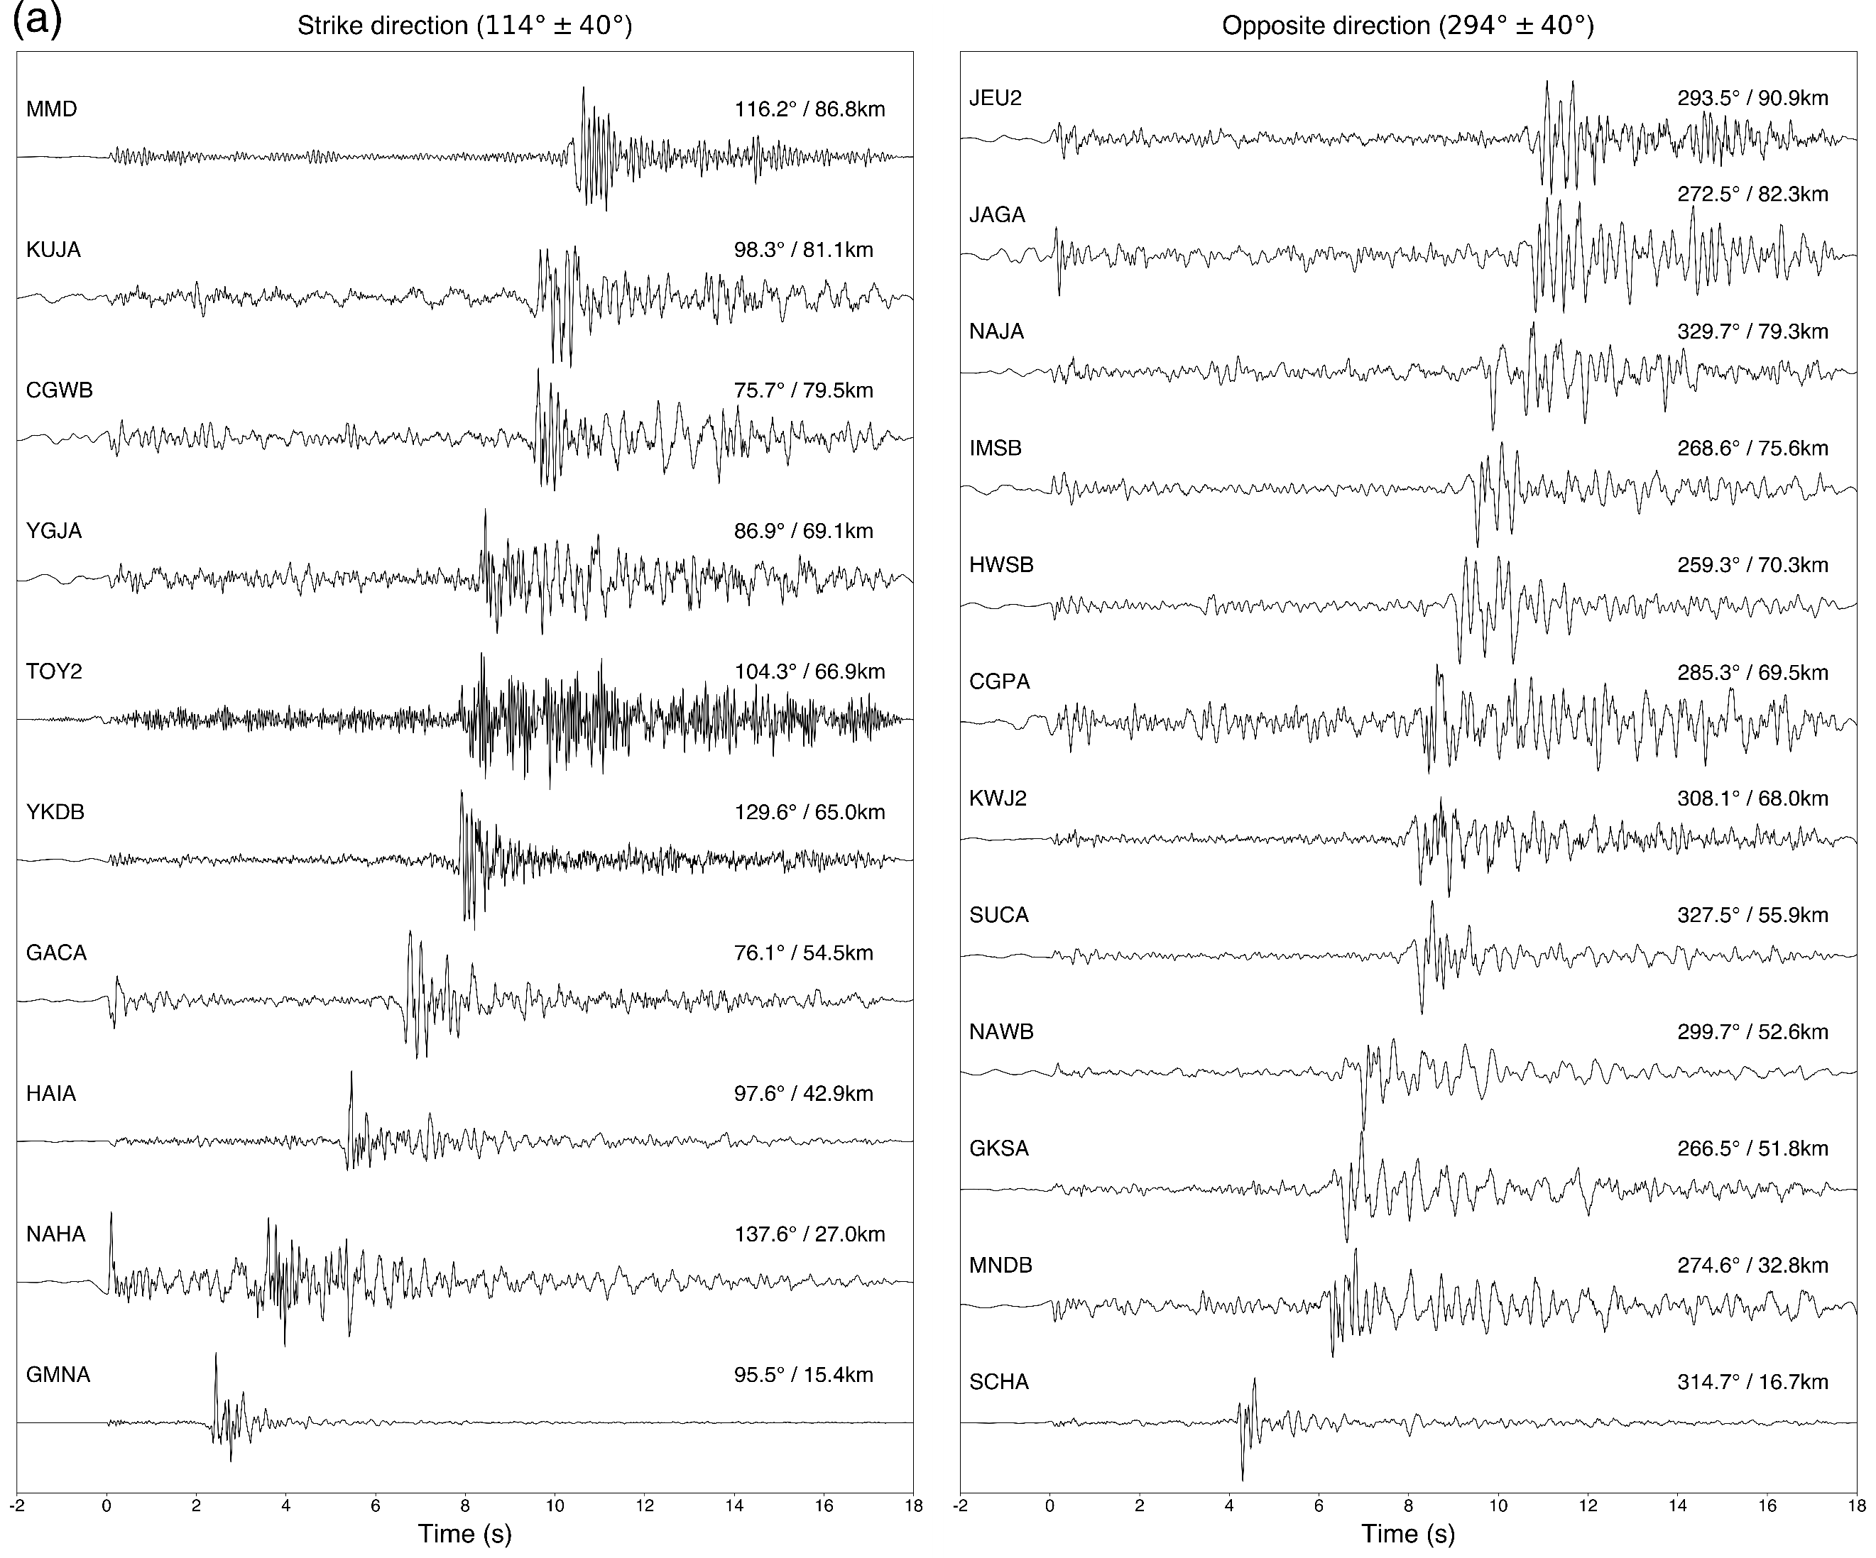

**Figure S1.** (a) Vertical-component displacement records from *M*L 2.2 Gwangyang main event are plotted aligned at *P* arrivals. 1 Hz-highpass filter is applied to suppress low-frequency noise. (*Left panel*) Records from stations situated at azimuth range of ±40º from the strike direction (114º) and distance range from 15 km to 87 km. (*Right panel*) Records from stations situated at azimuth range of ±40º from the opposite to strike direction (294º) and distance range from 17 km to 91 km. It is evident that the frequency contents of the records, mostly the *S*-wave arrival portion, along the strike direction are richer than those in the opposite direction.

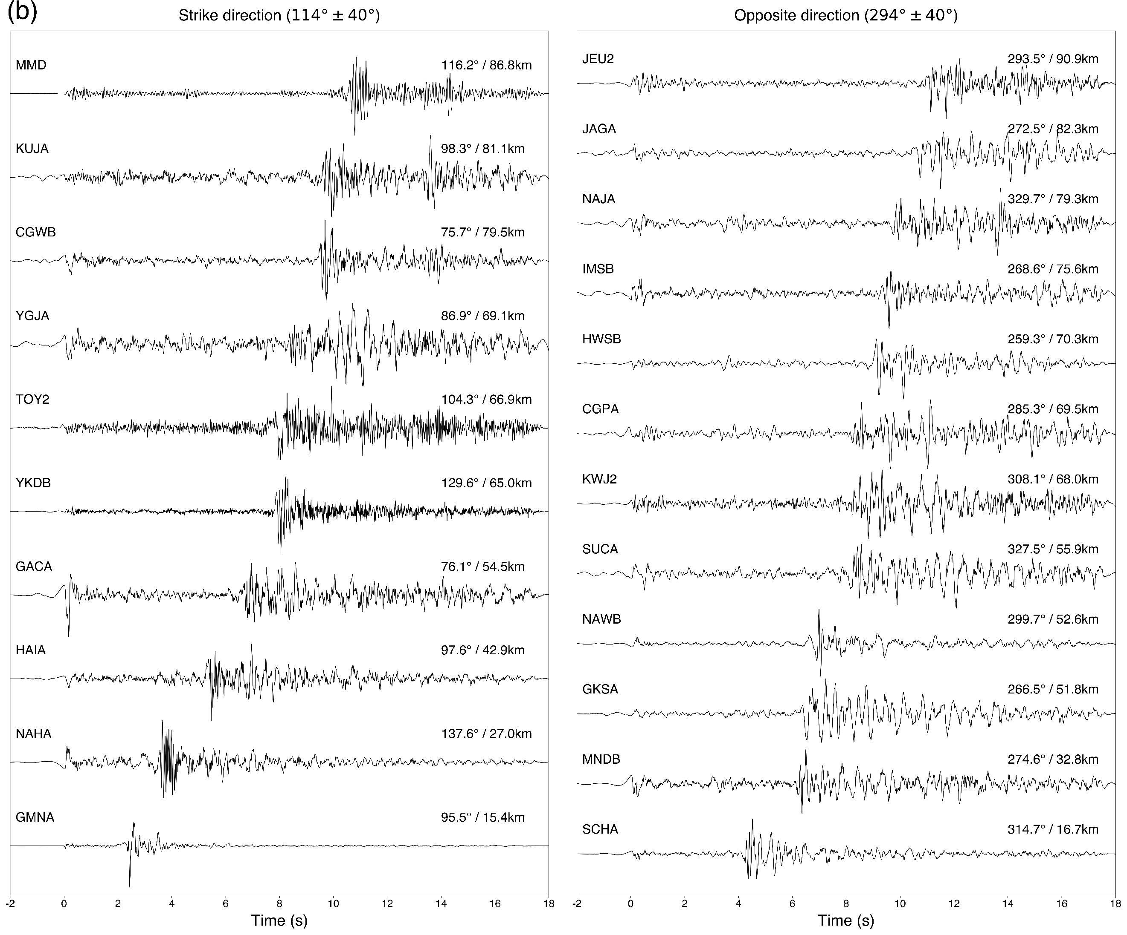

**Figure S1.** (b) Details are the same as in (a), but radial-component records are shown.

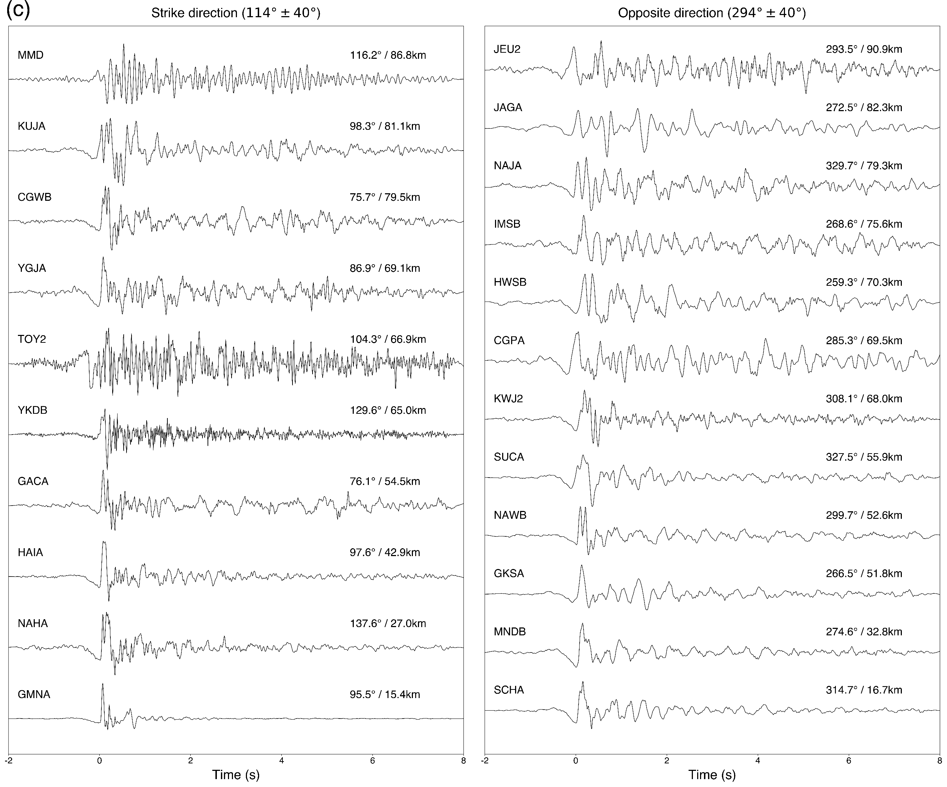

**Figure S1.** (c) Details are the same as in (a), but transverse-component records aligned at *S* arrivals are shown.



**Figure S2.** Composite *P*-wave first motion polarities from all six events at 29 stations are projected on a lower hemispheric focal sphere. Two nodal planes and the *P*- and *T*-axis of the double-couple focal mechanism of the *M*L 2.2 main event, are plotted as a reference. The focal mechanism of each event can be determined using polarity data but with considerable uncertainty. This composite plot indicates that all six events (*M*L 1.1-2.2) share a nearly identical focal mechanism. The first motions are plotted by circles (compressional, +) and triangles (dilatational, –). At each station, observed polarities from all events show identical polarity, either + or –, from any event, except at MMD, which shows + for event 4 and – for event 6. Ten stations that show identical polarities from all six events are plotted by filled symbols. The open symbols denote ten stations with the same polarities from four events and nine stations with the same polarities from two and three events.

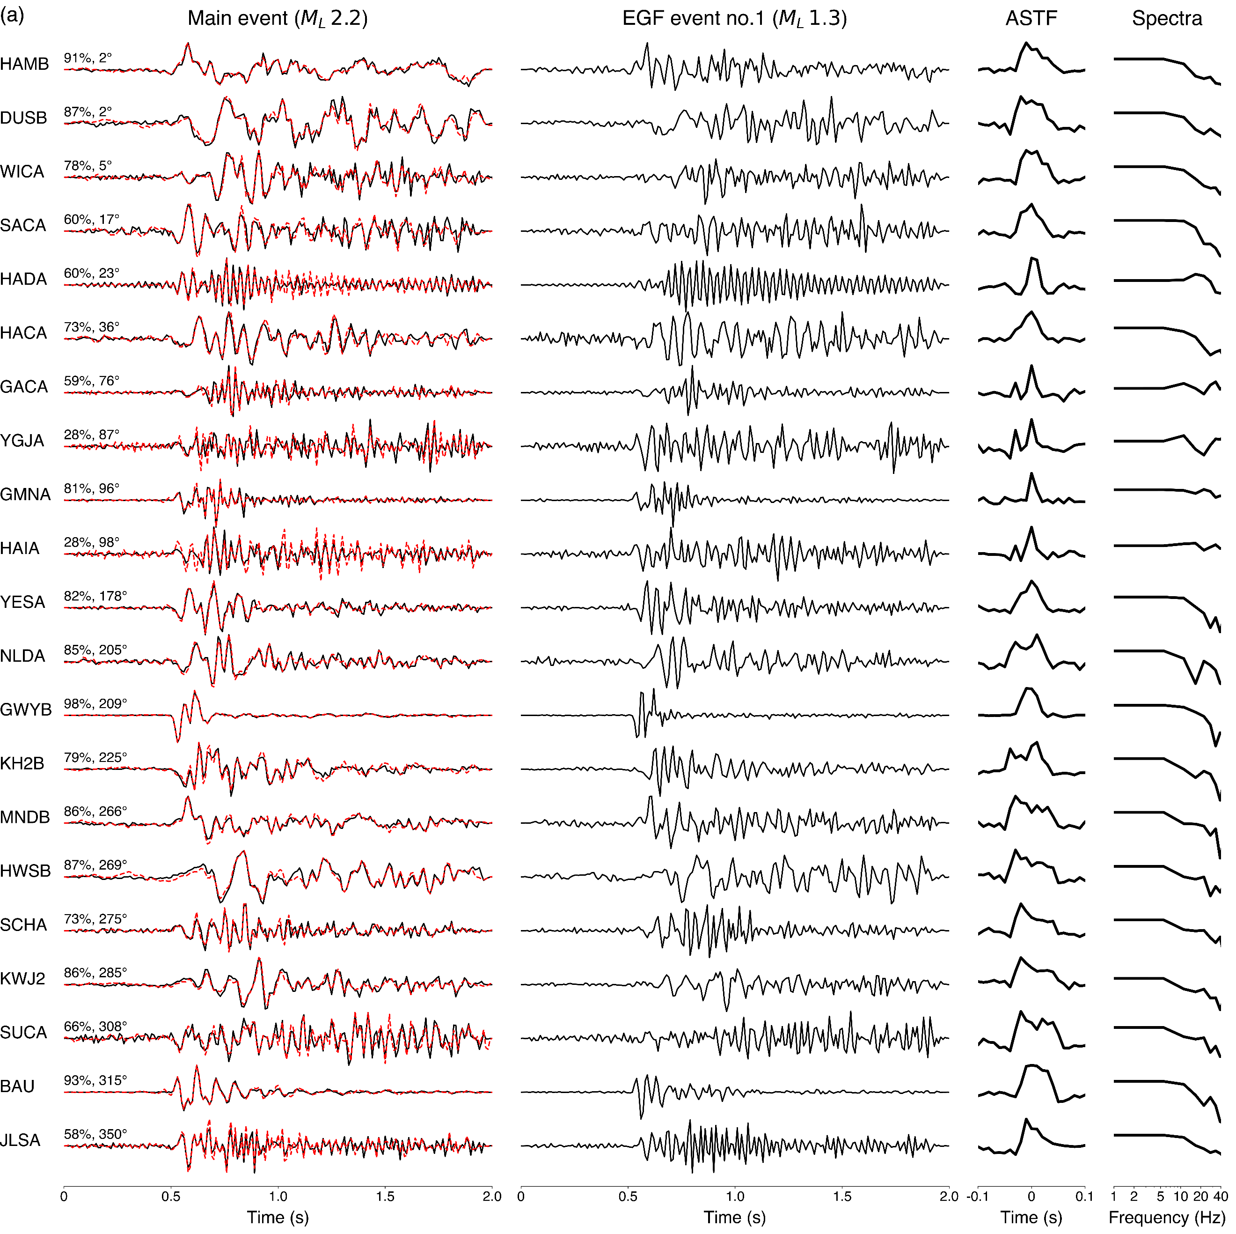

**Figure S3.** (a) Transverse-component records from *M*L 2.2 Gwangyang main event (column 1) and *M*L 1.3 foreshock (event 1) used as EGF (column 2) are plotted by their azimuth. 1 Hz-highpass filter is applied to both main and EGF event waveforms. Corresponding ASTFs at each station are plotted in the third column. Normalized source spectra obtained by applying Fourier transform to each ASTF are plotted in the fourth column. The quality of the STFs is indicated by variance reduction (VR) between observed (black) and synthetic (EGF⁕STF, red) traces at the beginning of each trace in the first column. Stations YGJA and HAIA, which are situated along the strike of the fault plane, show low VR values (28%). Station azimuth is indicated at the beginning of each trace after the VR.

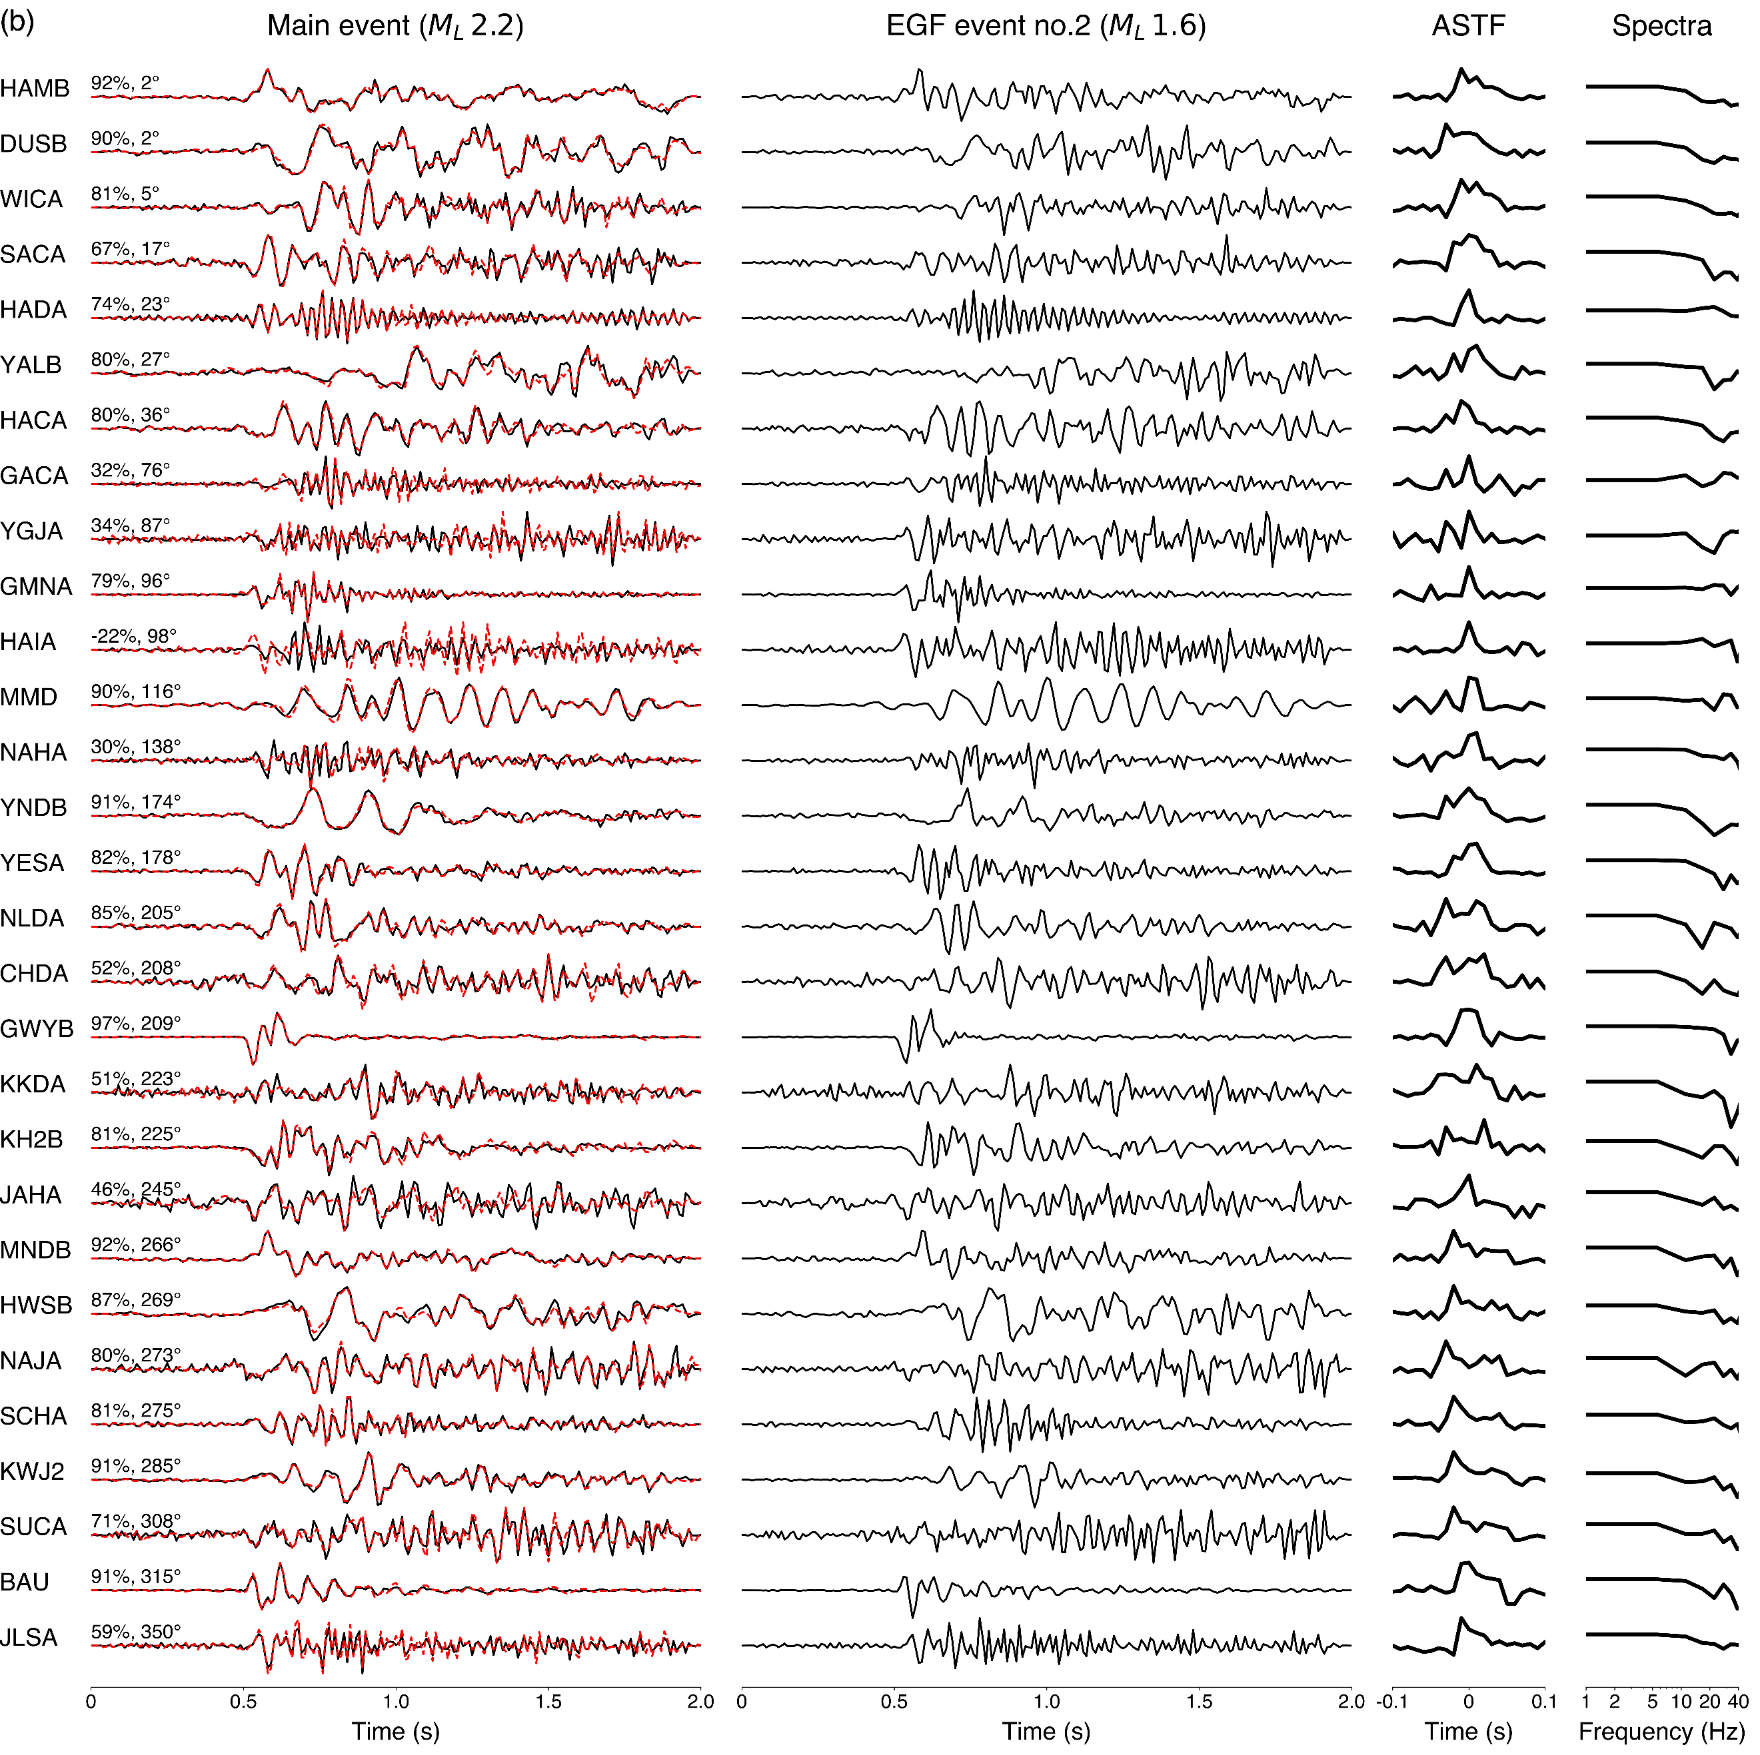

**Figure S3.** (b) Details are the same as in (a), but *M*L 1.6 foreshock (event 2) is used as EGF.

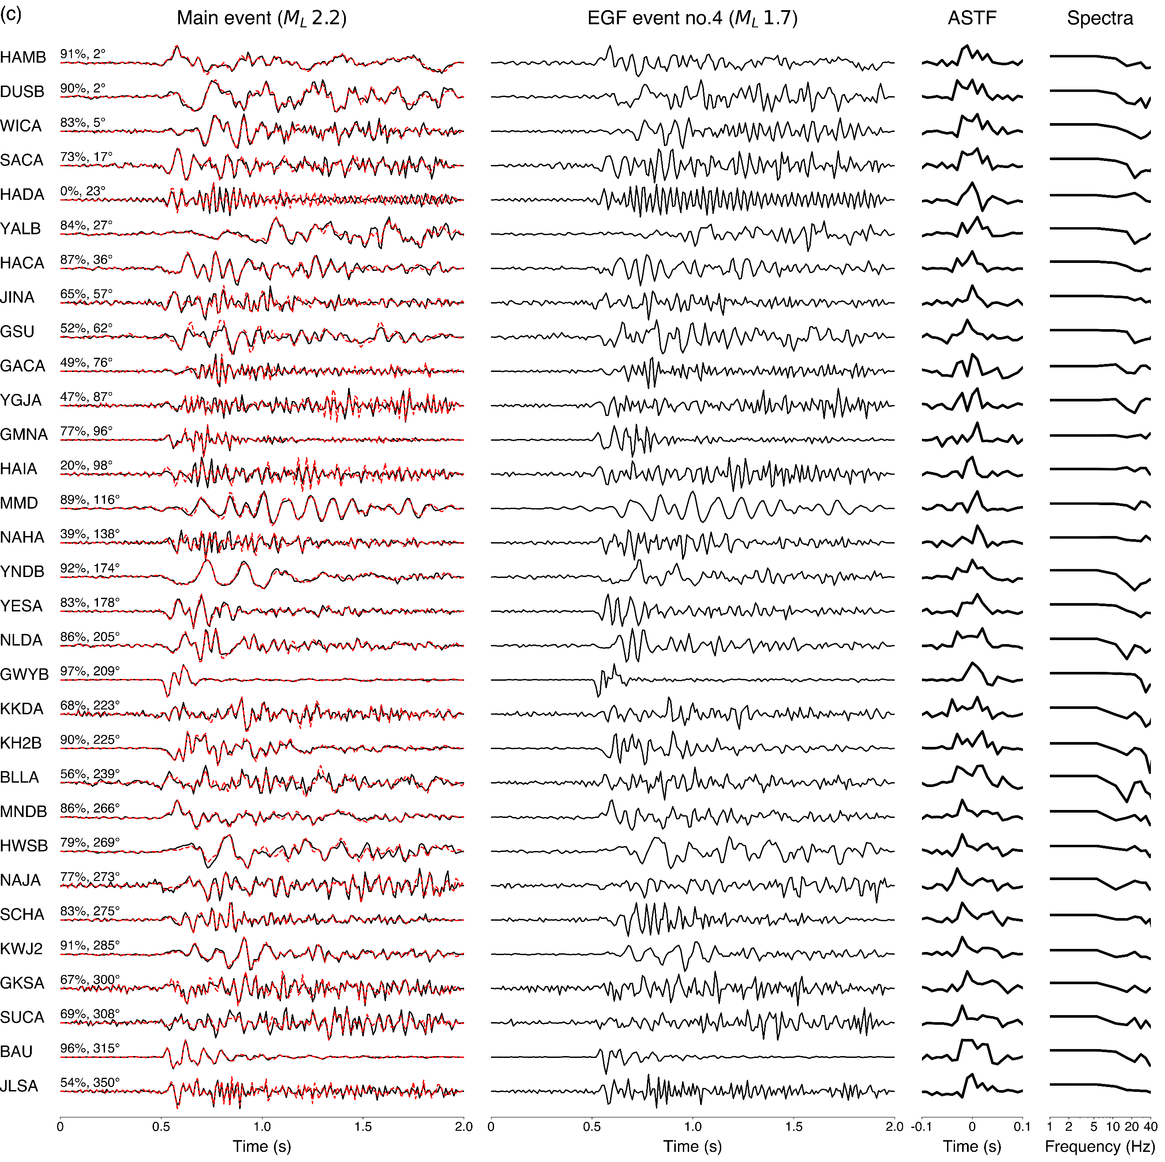

**Figure S3.** (c) Details are the same as in (a), but *M*L 1.7 aftershock (event 4) is used as EGF.

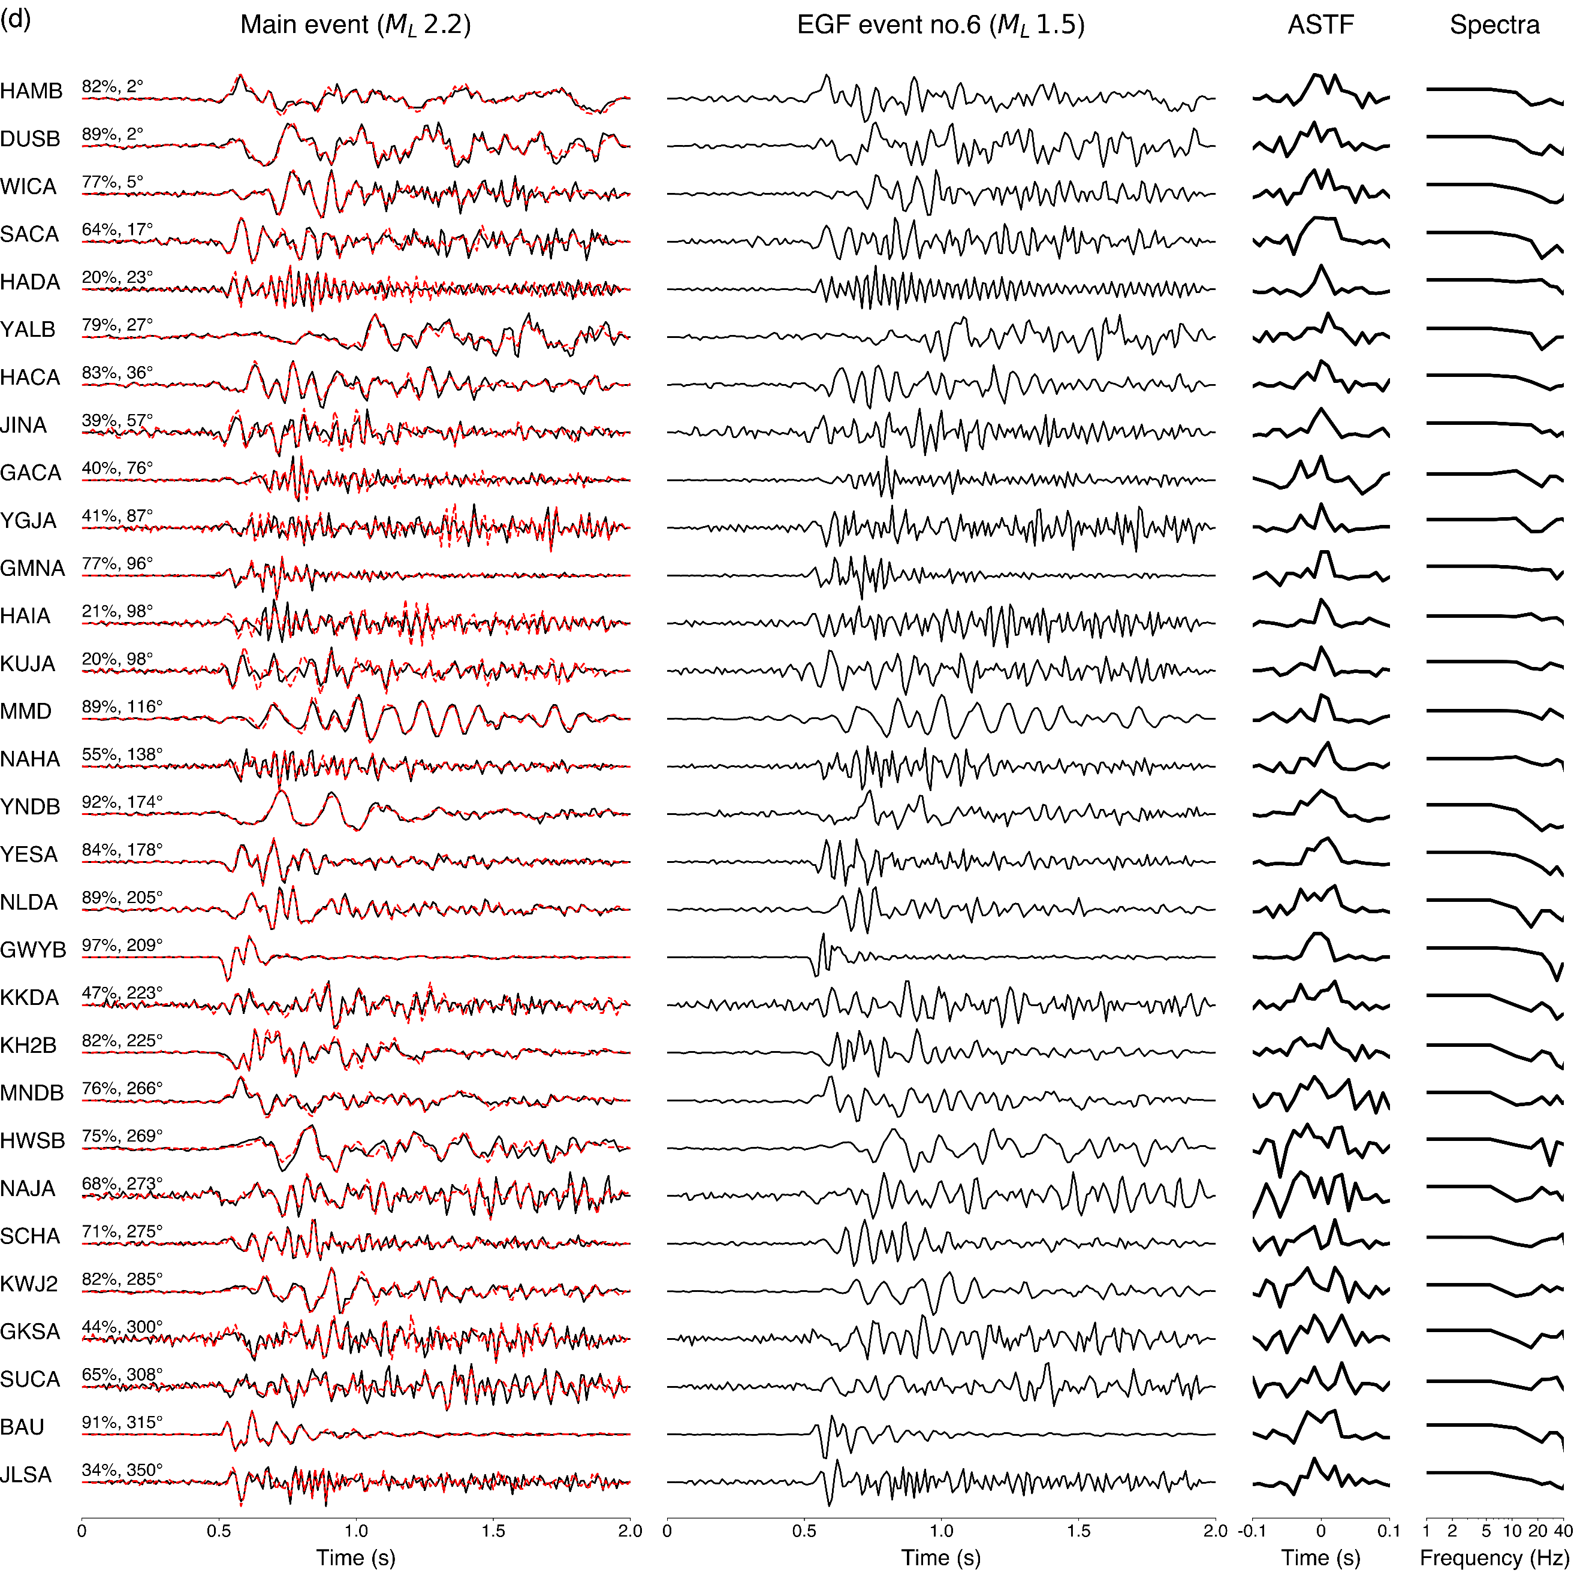

**Figure S3.** (d) Details are the same as in (a), but *M*L 1.5 aftershock (event 6) is used as EGF. Note that the ASTFs corresponding to stations situated in the azimuth range of 266°-308° are relatively unclear and noisy, although most are characterized by high (> 60%) VR values.

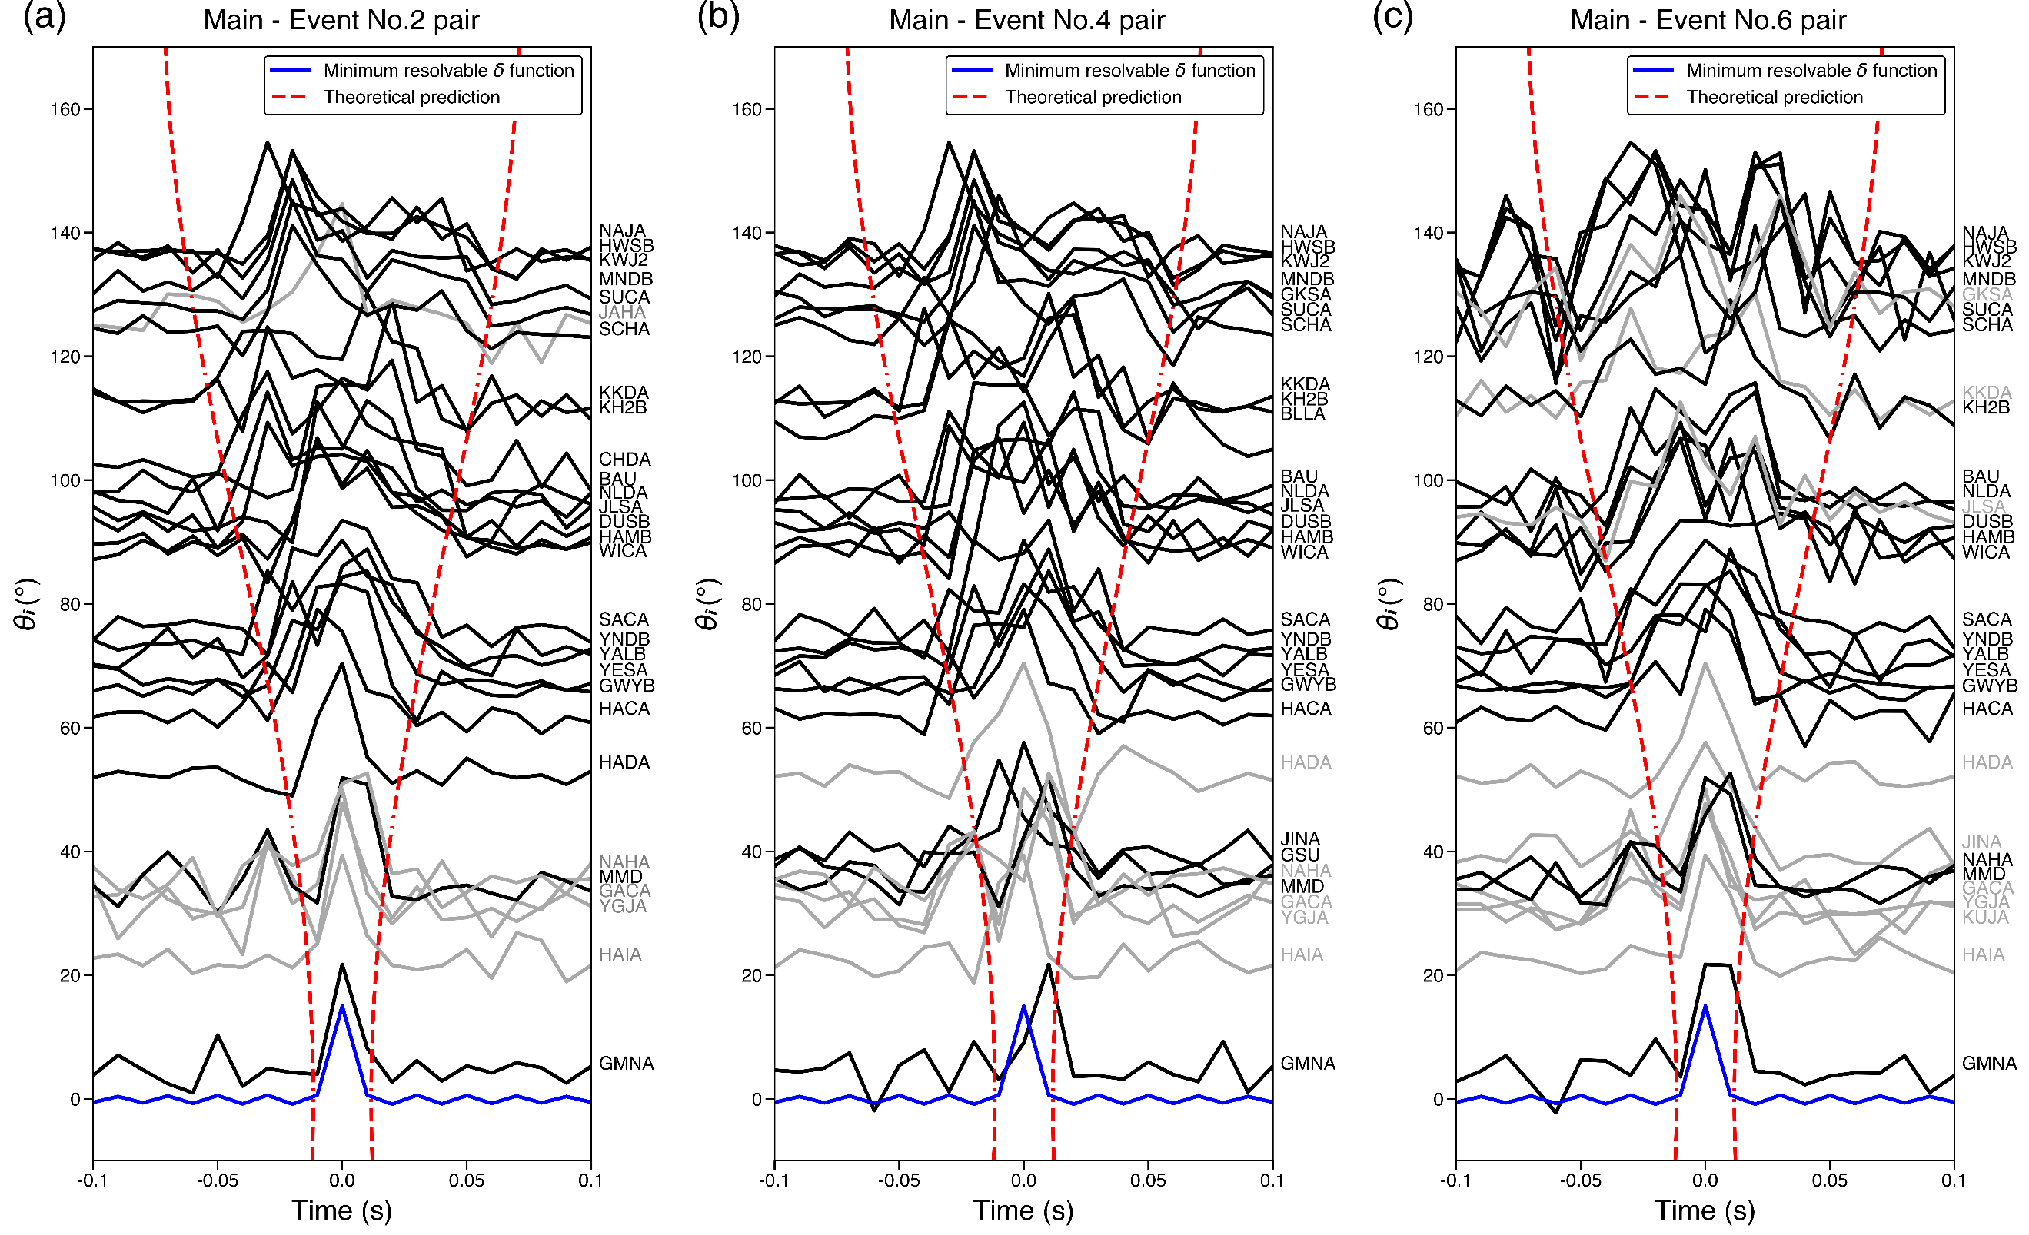

**Figure S4.** Alignment of ASTFs obtained using (a) event 2, (b) event 4, and (c) event 6 as EGF events by angle 𝜃𝑖. ASTFs at stations with low (< 50%) variance reduction values are shown as gray colors. Angle𝜃𝑖and theoretical duration curve (red dashed line) are both calculated based on the best-fit values derived from the STF stretching analysis, which is (rupture azimuth, rupture dip, velocity ratio)=(98.5°, 36.3°, 0.72). Overall, aligned ASTFs are consistent with theoretically predicted duration for all three cases, although ASTFs are relatively noisier when event 6 is used as EGF.

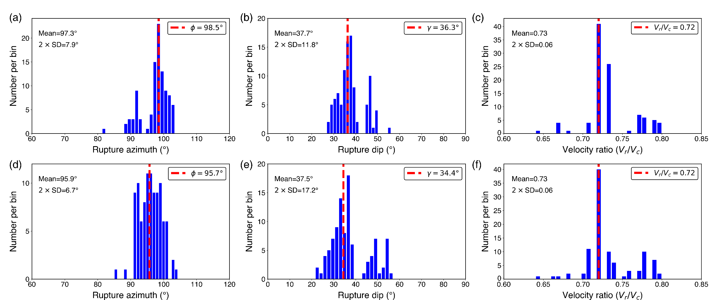

**Figure S5.** Distribution of rupture parameters (rupture azimuth, rupture dip, and velocity ratio) derived from bootstrap analysis. Directivity inversion is repeated 100 times by randomly removing 20 % (4 out of 19) of the total analyzed stations. (a)-(c) Distribution of inverted parameters by constraining parameter searching on the 2D fault plane. (d)-(f) Distribution of inverted parameters by parameter searching on the entire focal sphere. Red dashed lines mark the best-fit parameters found by using all stations. Average and two standard deviation values are also shown for each parameter.

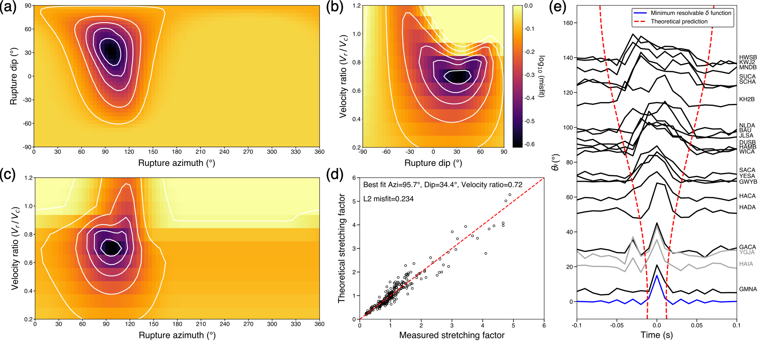

**Figure S6.** Grid search result for the best-fitting rupture parameters in 3-D space. (a)-(c) Misfit contours for the combinations of searched parameters. (d) Comparison of measured and theoretical stretching factors. (e) Alignment of 21 obtained ASTFs by angle 𝜃𝑖. Two ASTFs at stations YGJA and HAIA have low (< 50%) variance reduction values and are shown as gray colors. The theoretical curve (red dashed line) is calculated assuming the average rupture length of 216 m. The best-fitting parameter combination is (rupture azimuth, rupture dip, velocity ratio)=(95.7°, 34.4°, 0.72), which is highly similar to the parameters obtained from the 2-D fault plane analysis (rupture azimuth, rupture dip, velocity ratio)=(98.5°, 36.3°, 0.72). See the caption of Figure 4 for detail.